

**A**

**Report on**

**“Airline Management System”**

# Ayush Lokre

**[Roll No : A-60 ]**

# Rishabh Kothari

**[Roll No : A-54 ]**

**Under the Guidance of**

# Mrs.S.A.Belhe

**Assistant Professor, AI & DS Department**

**[SY BTech. Artificial Intelligence & Data Science]**

**AY (2023-2024)**

**At**

**DEPARTMENT OF ARTIFICIAL INTELLIGENCE & DATA SCIENCE**

# AISSMS IOIT Pune

**Affiliated to**



**SPPU**



***CERTIFICATE***

This is to certify that the report entitled ***“*Airline management system*”*** submitted by student **Ayush Naresh Lokre** is a record of work carried out by him, in partial fulfillment of requirement for Second Year of Engineering AI-DS at AISSMS IOIT Pune 411001. This work is done during the academic year 2023-2024, under our guidance.

Date:

Place: Pune



Guide [Mrs.S.A.Belhe] HOD, AI-DS **[** Dr.R.A.Jamadar]



***CERTIFICATE***

This is to certify that the report entitled ***“*Airline management system*”*** submitted by student **Rishabh Kothari** is a record of work carried out by him, in partial fulfillment of requirement for Second Year of Engineering AI-DS at AISSMS IOIT Pune 411001. This work is done during the academic year 2023-2024, under our guidance.

Date:

Place: Pune



Guide [Mrs.S.A.Belhe] HOD, AI-DS **[** Dr.R.A.Jamadar]

**Index**

| SR.no | Topic | Page.no |
| --- | --- | --- |
| 1 | Abstract | 1 |
| 2 | Hardware /Software Requirement | 1 |
| 3 | Methodology | 1 |
| 4 | Modules if any | 2 |
| 5 | Working | 3 |
| 6 | Features | 3 |
| 7 | Connectivity code (front end with back end) | 4 |
| 8 | Test Cases | 4 |
| 9 | Advantages/Limitation | 6 |
| 10 | Future Scope | 7 |
| 11 | Conclusion | 7 |
| 12 | References | 8 |

**Abstract:**

The Airline Management System (AMS) is a significant advancement in airline technology, revolutionizing the way airlines operate and enhancing the overall passenger experience. It leverages state-of-the-art digital tools to automate and optimize various aspects of airline management that were previously done manually. These include flight scheduling, resource allocation, ticketing, revenue management, crew scheduling, and maintenance planning.

One of the key benefits of the AMS is its ability to streamline operations, improve efficiency, and reduce costs for airlines. By automating repetitive tasks and providing real-time data insights, airlines can make data-driven decisions that lead to better resource utilization and increased profitability.

Moreover, the AMS is designed with a user-centric approach, focusing on delivering a seamless and personalized experience for passengers. This includes features such as online booking platforms, mobile check-in, personalized offers and promotions, and real-time flight updates.

Looking ahead, the AMS is poised for further advancements, with ongoing developments in artificial intelligence, machine learning, and data analytics. These technologies will enable the AMS to become even more intelligent and predictive, helping airlines anticipate passenger needs, optimize operations, and deliver exceptional service.

Overall, the AMS represents a fundamental shift in how airlines are managed, embracing digital innovation to drive efficiency, cost savings, and customer satisfaction in the aviation industry.

**Hardware / Software Requirements:**

**Operating System:** AMS is compatible with multiple operating systems, including Windows, Linux, and macOS. The choice of operating system for the server hosting Care Align depends on the organization's preferences and existing infrastructure.

**Web Server**: AMS relies on a web server to host the web application and serve web pages to users' browsers. Popular web servers such as Apache or Nginx are commonly used to deploy PHP-based web applications like Care Align.

**Database Management System (DBMS):** AMS utilizes MySQL as its database management system to store and manage structured data efficiently. MySQL offers robust features, scalability, and reliability, making it suitable for healthcare applications that require secure and scalable data storage

**Methodology:**

The Airline Management System (AMS) underwent meticulous development using the agile methodology, a modern approach known for its iterative and collaborative nature. Agile breaks down projects into manageable phases, allowing the development team to work in iterations and continuously refine the system. This iterative process ensures that the AMS evolves gradually, with each iteration incorporating feedback and improvements from stakeholders and users.

One of the key benefits of the agile methodology is its focus on adaptability and responsiveness to changing requirements. By working in short cycles, the AMS development team could quickly respond to new insights and adjust the system accordingly. This agility is crucial in an industry as dynamic as aviation, where market trends and customer preferences can shift rapidly.

Additionally, agile promotes collaboration and open communication within the team and with stakeholders. Regular meetings, such as daily stand-ups and sprint reviews, fostered a collaborative environment where issues could be addressed promptly, and progress could be tracked effectively.

By embracing agile, the AMS development team was able to deliver a robust and user-friendly system that meets the diverse needs of airlines and passengers. The iterative nature of agile ensured that the AMS was thoroughly tested and refined, resulting in a high-quality product that aligns closely with industry standards and user expectations.

The methodology adopted for developing the Airline Management System (AMS) plays a crucial role in its success and effectiveness. A contemporary approach such as agile methodology was chosen for its iterative and collaborative nature. Agile allows for the project to be broken down into manageable phases or iterations, with each iteration focusing on specific functionalities or features. This iterative development process promotes continuous feedback and adaptation, ensuring that the AMS evolves in line with changing requirements and user feedback.

Furthermore, agile methodology fosters collaboration among team members, stakeholders, and end-users. Regular meetings, such as sprint reviews and daily stand-ups, facilitate open communication, transparency, and quick decision-making. This collaborative environment enables the AMS development team to address challenges promptly, make informed decisions, and prioritize tasks effectively, ultimately leading to the successful delivery of a robust and user-friendly system.

**Modules:**

Booking management is a core component of the Airline Management System (AMS), encompassing various functionalities essential for seamless passenger experiences and efficient airline operations. This module facilitates seat allocation, ticketing, payment processing, and reservation management, streamlining the booking process for passengers and ensuring accurate record-keeping for airlines. By offering user-friendly interfaces and integration with multiple payment gateways, the booking management module enhances convenience, security, and flexibility for passengers while enabling airlines to optimize revenue streams and resource utilization.

The airline management module within the AMS is fundamental for overseeing and optimizing flight operations. It includes features for flight scheduling, resource allocation, and real-time monitoring of flight statuses. This module enables airlines to create and manage flight schedules efficiently, allocate resources such as aircraft and crew members effectively, and respond promptly to operational changes or disruptions. By centralizing critical flight management functions, the airline management module contributes to improved operational efficiency, cost-effectiveness, and overall customer satisfaction.

Passenger management is another key aspect of the AMS, focusing on passenger registration, profile management, and booking processing. This module ensures that passenger data is securely stored and easily accessible, allowing airlines to provide personalized services, manage loyalty programs, and offer tailored promotions based on passenger preferences and booking history. By integrating passenger management functionalities, the AMS enables airlines to enhance customer relationships, drive customer loyalty, and deliver superior travel experiences.

Crew management is integral to the smooth functioning of airlines and is supported by the AMS through features for crew assignment, scheduling, and management. This module optimizes crew deployment, ensures compliance with regulatory requirements and safety protocols, and facilitates effective communication and coordination among crew members. By streamlining crew management processes, the AMS contributes to operational safety, efficiency, and regulatory compliance, ultimately supporting airlines in delivering reliable and safe flight services to passengers.

By integrating these modules seamlessly within the Airline Management System, airlines can streamline operations, enhance productivity, and deliver a superior passenger experience. The cohesive nature of these modules allows for centralized management of key airline functions, promoting efficiency, accuracy, and cost-effectiveness in airline operations.

**Working:**

The Airline Management System operates harmoniously thanks to its well-structured frontend and backend components, working seamlessly together to ensure efficient connectivity and functionality. The system's architecture is meticulously designed to facilitate smooth interactions between users and the system, enhancing user experience and operational effectiveness. Passengers accessing the system are greeted with an intuitive frontend interface that offers a range of features, including flight search, booking options, profile management tools, and the ability to view their itinerary. This user-friendly interface simplifies the booking process and empowers passengers to manage their travel plans with ease.

On the other hand, airline administrators are equipped with a robust backend control panel that serves as the nerve center of the system. This control panel provides comprehensive tools and functionalities for managing various aspects of airline operations, such as flight management, reservation processing, crew scheduling, reporting, and system configuration. The backend architecture is designed to handle complex operations efficiently, ensuring that airline administrators can effectively monitor and manage critical tasks, streamline processes, and make informed decisions to optimize airline performance.

At the core of the system's functionality lies a robust backend logic that powers its operations. This backend logic is meticulously crafted to handle intricate tasks such as data storage, retrieval, manipulation, and transaction processing. Leveraging Python as the scripting language and MySQL as the relational database management system (RDBMS), the backend architecture ensures data integrity, security, and scalability. Python's versatility and MySQL's reliability enable the system to manage vast amounts of data securely, support concurrent user interactions, and adapt to evolving business requirements.

By leveraging a sophisticated backend architecture, the Airline Management System is equipped to meet the dynamic demands of airline operations and passenger services. The backend's resilience, security features, and scalability empower the system to handle large volumes of data, support multiple user interactions, and deliver a seamless and efficient experience for both passengers and airline administrators.

The Airline Management System (AMS) operates smoothly thanks to its cleverly designed frontend and backend parts that work well together to make sure everything runs smoothly. When passengers log in, they see an easy-to-use interface with options to search for flights, book tickets, manage their profile, and view their travel plans. This simple design helps passengers book their flights easily and manage their trips without any hassle.

On the other hand, airline administrators have access to a powerful backend control panel. This panel gives them all the tools they need to manage different parts of airline operations like flights, reservations, crew schedules, reports, and system settings. The backend system is designed to handle complex tasks efficiently, allowing administrators to monitor operations, streamline processes, and make informed decisions to improve airline performance.

Behind the scenes, a smart backend logic manages data storage, retrieval, and processing. This backend system uses Python for scripting and MySQL for managing databases, ensuring that data is kept secure, accurate, and scalable. With this strong backend structure, the AMS can handle large amounts of data, support multiple users, and provide a seamless experience for passengers and administrators alike.

**Features:**

The Airline Management System comes packed with a variety of tools to meet the needs of both airline staff and passengers. These tools include Flight Management, which lets staff add, change, or cancel flights, assign crew members, and keep track of available planes; Passenger Management, which handles passenger sign-ups, profile updates, booking processing, and loyalty program connections; Booking Management, where seats are assigned, tickets are issued, payments are processed, and reservations are managed; Crew Management, overseeing crew assignments, schedules, and qualifications; Admin Control Panel, offering tools to manage flights, bookings, staff, and system settings; and Real-time Updates, sending instant notifications to passengers and staff about flight changes, booking confirmations, and other important updates. These tools work together to improve efficiency, enhance the passenger experience, and make airline management smoother overall.

Flight Management in the Airline Management System allows staff to add, edit, or cancel flights as needed. They can also assign crew members to flights and keep track of which planes are available.

Passenger Management is another essential feature, handling tasks like signing up passengers, updating their profiles, processing bookings, and linking to loyalty programs.

Booking Management is where seat assignments, ticketing, payment processing, and reservation handling take place, streamlining the booking process for passengers.

Crew Management oversees crew assignments, schedules, and qualifications, ensuring that the right crew members are assigned to the right flights at the right times.

The Admin Control Panel is a comprehensive tool for managing all aspects of flights, bookings, staff, and system configurations, providing airline staff with the tools they need to keep operations running smoothly.

Real-time Updates send instant notifications to passengers and staff about any changes to flight statuses, booking confirmations, and other important information, keeping everyone informed and up to date. Together, these features make airline management more efficient, improve the passenger experience, and enable comprehensive administration within the airline ecosystem.

**Connectivity Code (Frontend with Backend):**

import streamlit as st

import sqlite3

import pandas as pd

from datetime import datetime

import base64

# Database connection

conn = sqlite3.connect("airline.db", check_same_thread=False)

c = conn.cursor()

**Test Cases:**

A comprehensive set of test cases is essential to ensure the reliability and functionality of the Airline Management System under various scenarios. Test cases include validating flight search functionality, booking process functionality, admin login security and functionality, flight management, and reporting and analytics accuracy. For example, the flight search test case verifies the functionality of the flight search feature by entering valid search criteria and verifying that the search results match the entered criteria. Similarly, the booking process test case validates the booking process functionality by selecting a flight, entering passenger details, and completing the booking process, ensuring that the booking is successfully processed and a confirmation message is displayed. By conducting thorough testing across different aspects of the system, potential issues and bugs can be identified and addressed, ensuring that the system operates reliably and effectively for users.

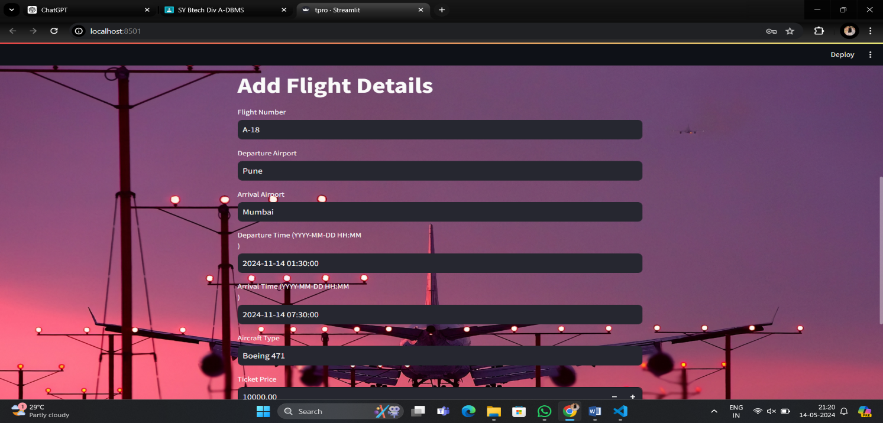

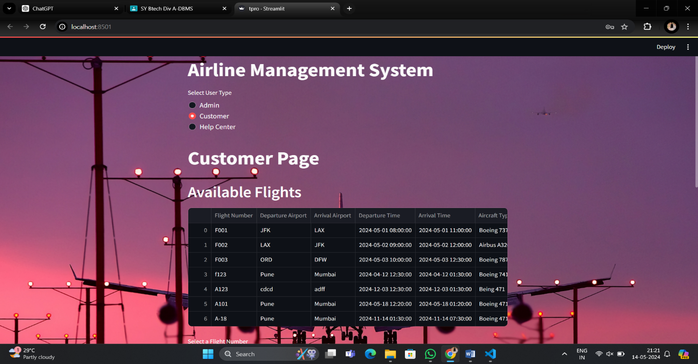

**Advantages/Limitations:**

The Airline Management System is equipped with a wide range of tools to meet the needs of both airline staff and passengers. These tools include Flight Management, which helps staff add, change, or cancel flights, assign crew members, and keep track of available planes. It also includes Passenger Management, which handles passenger sign-ups, profile updates, booking processing, and loyalty program connections.

Booking Management is another crucial feature, managing tasks like seat assignments, ticketing, payment processing, and reservation handling. Meanwhile, Crew Management oversees crew assignments, schedules, and qualifications, ensuring that the right crew members are assigned to the right flights at the right times.

The Admin Control Panel is a central hub for managing flights, bookings, staff, and system settings, providing airline staff with the necessary tools to keep operations running smoothly. Additionally, Real-time Updates send instant notifications to passengers and staff about any changes to flight statuses, booking confirmations, and other important information.

All these features work together seamlessly to improve efficiency, enhance the passenger experience, and facilitate comprehensive administration within the airline ecosystem. They make airline management simpler and more effective for both staff and passengers.

The Flight Management aspect of the Airline Management System is crucial for ensuring smooth and efficient airline operations. This module allows airline administrators to add new flights to their schedule, update existing flight details, and cancel flights when necessary. It also enables them to assign qualified crew members to each flight and manage the availability of aircraft. By centralizing these functions within the system, Flight Management helps streamline the planning and execution of flights, ultimately contributing to improved operational efficiency and customer satisfaction.

On the passenger side, the Passenger Management module plays a vital role in providing a seamless booking experience and personalized services. Passengers can register their details, manage their profiles, and easily process bookings through the system. Moreover, the integration of loyalty programs allows airlines to reward loyal customers and offer tailored promotions, fostering customer loyalty and retention. The Passenger Management module enhances the overall passenger experience by offering convenient booking options, personalized services, and incentives for continued engagement with the airline.

Together, these modules, along with Booking Management, Crew Management, Admin Control Panel, and Real-time Updates, form a comprehensive Airline Management System that addresses the diverse needs of airline administrators and passengers alike. By leveraging these features, airlines can optimize their operations, improve customer satisfaction, and stay competitive in the dynamic aviation industry.

**Future Scope:**

Looking into the future, the Airline Management System is poised for exciting enhancements and advancements that will significantly boost its functionality and relevance in the aviation industry. One potential avenue for growth is the integration of third-party APIs, which can expand the system's capabilities and facilitate seamless data exchange with external platforms. This integration could unlock new functionalities such as enhanced booking options, real-time flight information from external sources, and improved connectivity with partner airlines and travel agencies. By harnessing the power of external APIs, the AMS can provide a more comprehensive and connected experience for both airline administrators and passengers.

Another area of future development is the implementation of advanced analytics and machine learning algorithms within the AMS. By leveraging flight data, passenger behavior patterns, and operational insights, the system can derive valuable insights that drive decision-making and optimization. For instance, predictive maintenance algorithms can help airlines anticipate and prevent aircraft maintenance issues, leading to improved reliability and cost savings. Moreover, machine learning algorithms can enable demand forecasting, personalized recommendations for passengers, and dynamic pricing strategies, enhancing revenue generation and customer satisfaction.

Furthermore, the development of a mobile application to complement the existing web-based system holds immense potential for enhancing user experience and accessibility. A mobile app can provide users with on-the-go access to flight information, booking capabilities, and personalized notifications. Additionally, offline functionalities can ensure a seamless experience even in areas with limited internet connectivity, catering to the diverse needs of passengers across different scenarios.

Lastly, adapting the system for internationalization and localization will be critical for expanding its reach and usability globally. This involves implementing features that support multiple languages, currencies, and regional preferences, ensuring that the AMS can cater to diverse audiences worldwide. By embracing internationalization and localization, the system can enhance its market penetration, improve user adoption, and deliver a more tailored experience to users from different regions and backgrounds.

Continuing on the path of future enhancements, the Airline Management System can also benefit from advancements in cybersecurity measures to ensure data privacy and protection. Strengthening the system's security protocols, implementing encryption standards, and regularly conducting security audits can safeguard sensitive information, prevent unauthorized access, and build trust among users.

Additionally, exploring opportunities for automation and artificial intelligence (AI) integration can further streamline operations and enhance decision-making within the AMS. Automated processes for routine tasks such as check-in procedures, baggage handling, and customer service inquiries can reduce manual workload, improve efficiency, and free up resources for more strategic initiatives. Moreover, AI-powered analytics can provide deeper insights into customer preferences, market trends, and operational efficiencies, enabling airlines to make data-driven decisions and deliver personalized experiences to passengers.

By embracing these future-focused initiatives, the Airline Management System can stay at the forefront of innovation, improve operational efficiency, enhance user experience, and maintain competitiveness in the evolving aviation landscape.

**Conclusion:**

In conclusion, the Airline Management System represents a significant advancement in streamlining airline operations and improving passenger services, offering a robust platform for efficient management and growth in the aviation industry. By leveraging modern technologies, intuitive interfaces, and data-driven insights, the system empowers airline companies to optimize operations, enhance customer experiences, and drive business success. As the aviation landscape continues to evolve, the Airline Management System stands poised to adapt and innovate, ensuring its continued relevance and impact in shaping the future of air travel. With ongoing enhancements and advancements, the system is well-positioned to meet the dynamic demands of the aviation industry and deliver value to stakeholders across the ecosystem.

**References:**

1. Python Documentation. Retrieved from <https://www.python.org/doc/>
2. MySQL Documentation. Retrieved from <https://dev.mysql.com/doc/>
3. Streamlit Documentation. Retrieved from https://docs.streamlit.io/
4. Agile Alliance. (2022). Agile Manifesto. Retrieved from <https://agilemanifesto.org/>
5. Pressman, R. S., & Maxim, B. R. (2014). Software engineering: a practitioner's approach. McGraw-Hill Education.
6. Sommerville, I. (2015). Software engineering. Pearson Education Limited.